MARKETING FUNNEL BASICS, METRICS & RATIOS
Tasks
1.Draw a simple marketing funnel for an app you use daily (like Zomato or Instagram) and label each stage (Awareness, Interest, Consideration, Conversion, Loyalty) with a real example action a user might take at that stage.
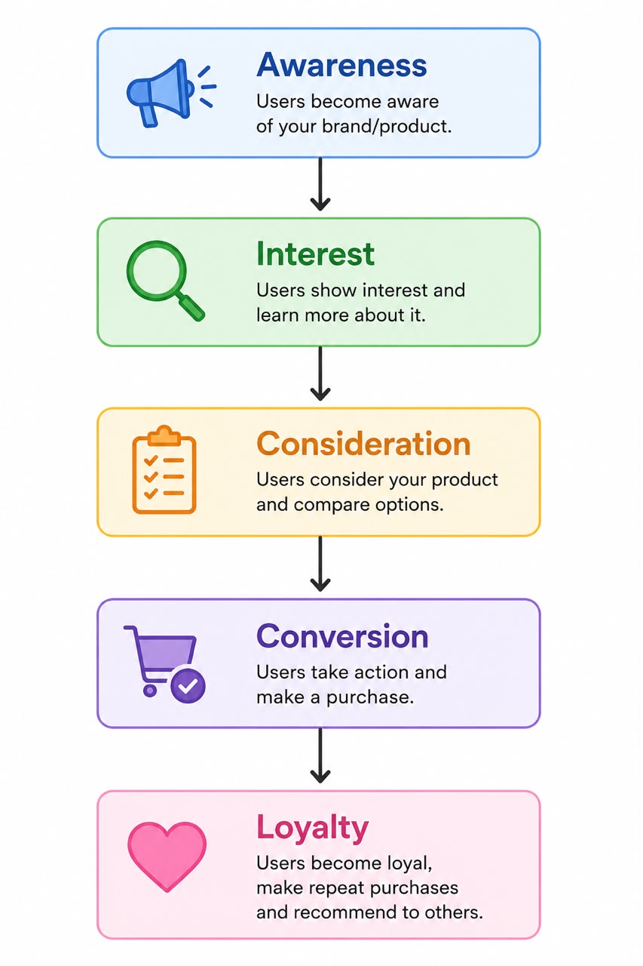

2.Create a table showing at least 3 key metrics for each stage of the marketing funnel for Flipkart (e.g., Impressions, Click-Through Rate, Add to Cart, Purchases, Repeat Orders).

Stage | Metrics 1 | Metrics 2 | Metrics 3
Awareness | Impressions | Reach | Websites Visits
Interest | Click-Through Rate(CTR) | Product Views | Sessions Duration
Consideration | Add to Cart | Wishlist Adds | Cart Abadonment Rate
Conversion | Purchases | Conversion Rate | Revenue
Loyalty | Repeat Orders | Customers Retention Rate | Customer Lifetime Value(CLV)

3.Given these sample numbers for a food delivery campaign: 10,000 people saw the ad, 1,200 clicked, 300 installed the app, and 60 placed an order. Calculate the conversion rate between each stage and overall.<br><br><em><strong>Hint:</strong> Conversion rate = (Next stage / Previous stage) x 100%</em>

Stage | Calculation | Results
Reach->Click | (1200/10000)*100 | 12%
Click->Install | (300/1200)*100 | 25%
Install->Order | (60/300)*100 | 20%
Overall(Reach->Order) | (60/10000)*100 | 0.6%

4.Pick any one metric from your previous table (e.g., Click-Through Rate or Repeat Purchase Ratio). Explain in 2-3 lines how a digital marketer could use this metric to improve their campaign for a music streaming app like Spotify.
=>Answer :
Click-Through Rate (CTR) shows the percentage of people who click on an advertisement after seeing it.
A digital marketer uses CTR to understand how effective an advertisement is. If the CTR is low, they can improve the ad by changing the headline, image, or call-to-action to attract more users.

